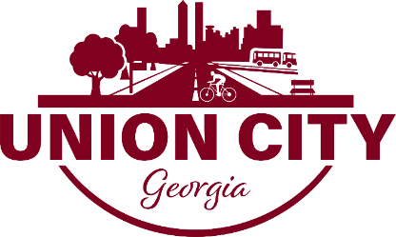

August 21, 2026

The Union City Development Authority Meeting is scheduled for Tuesday, September 8 at 9:00am in Council Chambers.

