Agenda
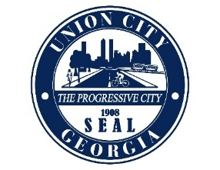
City Council SPECIAL CALLED Meeting
Friday, January 14, 2022
2:30 P.M.
In Council Chambers

ROLL CALL:
I. CALL TO ORDER:
II. NEW BUSINESS:
- Council to approve a Declaration of a state of Local Emergency for Union City.
III. ADJOURNMENT:

